Insurance Claims- Fraud Detection



Insurance fraud is an illegal work from the buyer or seller side of an insurance industry. It happen when a customer attempts to get some benefit which they are not entitled to, also when an insurer knowingly denies some benefit that is due and knowingly makes a fake claim, exaggerating or adding items to it, or in any way being fraudulent to gain more than legal entity. There is huge losses occur while identification of fraud claims. The manual way of identifying the fraudulent claims will not work as the data size increases. It will become challenging to predict these claims as the new types of claims arise.

Objective:
This blog focuses on claim data of a car insurance company. Therefore, it is important to know which claims are correct and which are not. The challenge behind fraud detection in machine learning is that frauds are far less common as compared to legit insurance claims. It is not possible for insurance companies to check all claims personally since this will take too much time and money.

Motivation:
Project dataset consists of the details of the insurance policy along with the customer details. It also has the details of the accident on the basis of which the claims have been made. Here, we are working with some auto insurance data to demonstrate a predictive model that predicts if an insurance claim is fraudulent or not. We have trained and built a Machine Learning model to help the Auto Insurance industry with this problem.

Furthermore, we use machine learning to predict which claims are likely to be fraudulent. This information can narrow down the list of claims that need a further check. It enables an insurer to detect more fraudulent claims. The aim of this project is to build a ML model on the basis of dataset we have, that can detect if an insurance claim is fraudulent or not.
In this blog, different machine learning techniques for fraud detection are taken into consideration and their performance on data sets examined. The impact of feature engineering, feature selection and parameter tuning are explored with the objective of achieving predictive performance.

Data Source:
https://github.com/dsrscientist/Data-Science-ML-Capstone-Projects/blob/master/Automobile_insurance_fraud.csv

Importing the required libraries

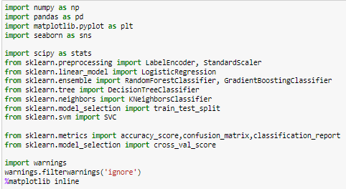

Loading of dataset

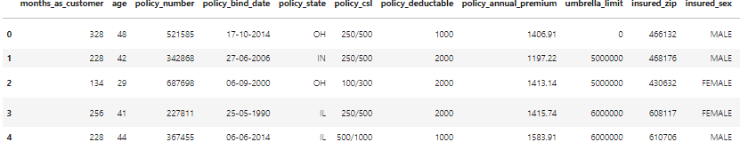

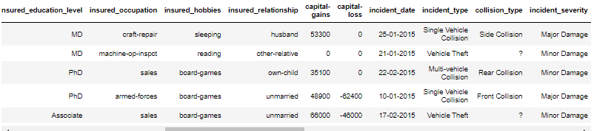
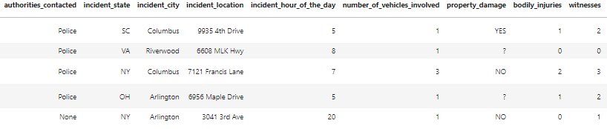

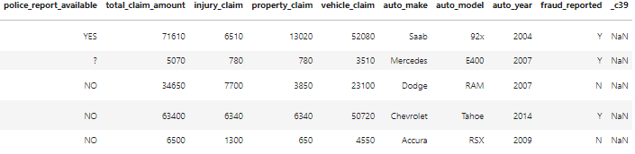

In this project, the given dataset contains 1000 rows and 40 columns including target column having the details of the insurance policy along with the customer details..

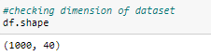
Dataset Summary
Using info() function, we get concise summary of the dataset which consist of columns, data types, non null values and memory usage.
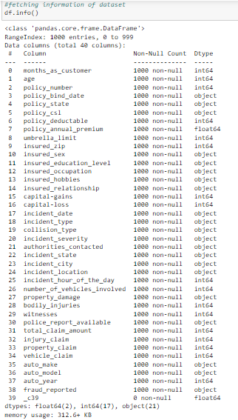
For above summary we see that there are 3 data types (i.e int64, float64, object) and one column _c39 with all null values. However, for further analysis categorical column will be converted to numeric value as machine learning model takes numeric data.
Finding the null values from the dataset and if found will be modified fillna using mean/mode or by deleting row/columns as per requirement.
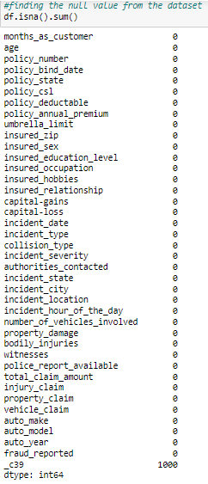
Conclusion: we can drop _c39 and Policy number from dataset as they both not help us in predicting the model.
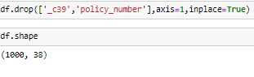
Columns value count:
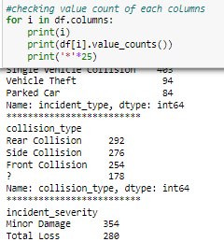

Inspecting value count we get 'police_report_available' contains 343 '?' , 'property_damage' contains 360 '?' ,'collision_type' contains 178 '?' character.So, we are replacing them with coumn maximum count

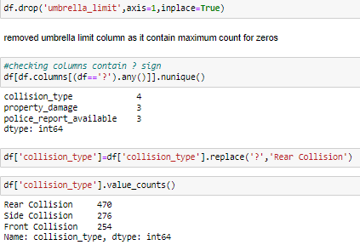
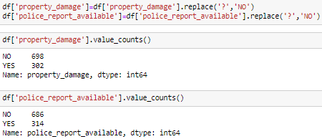
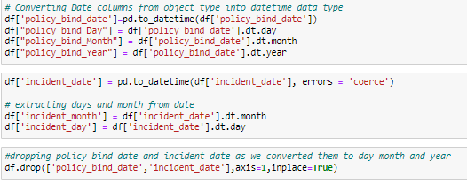
- Separating the dataframe into categorical columns and numerical columns

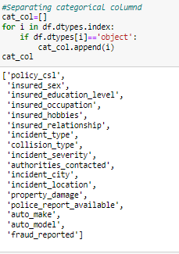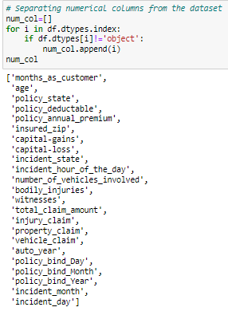

Here we are using describe() method which tell us some statistical data like percentile, mean and std of the numerical values of the DataFrame.
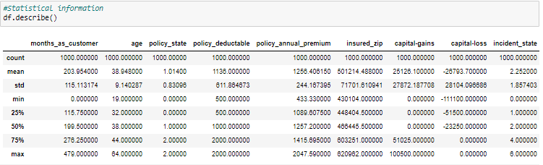
- 50 % of insurance claims has 0 Capital gains
- total_claim_amount,injury_claim, property_claim has a large difference between their Mean and 50% median
- We have outliers and skewness which needs to be removed

Univariate Analysis

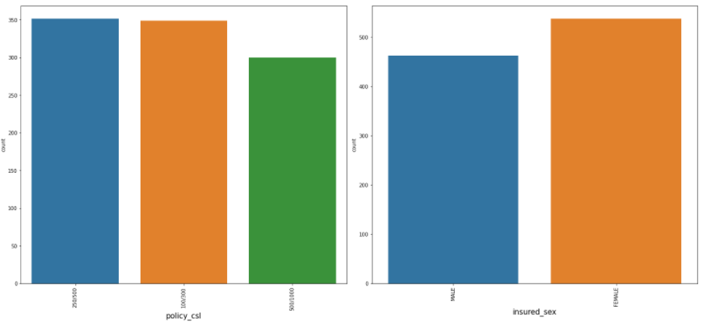
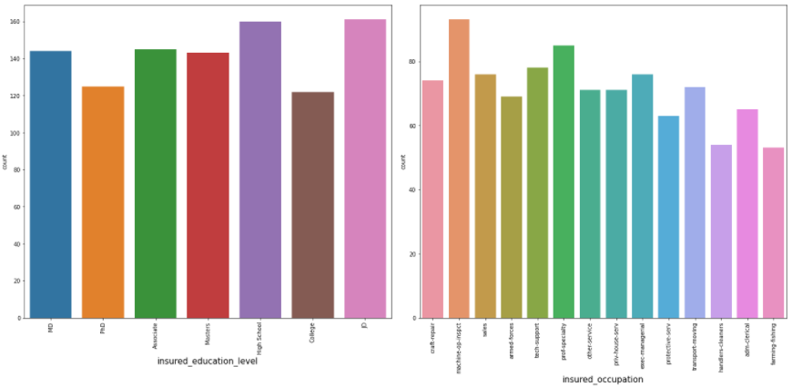
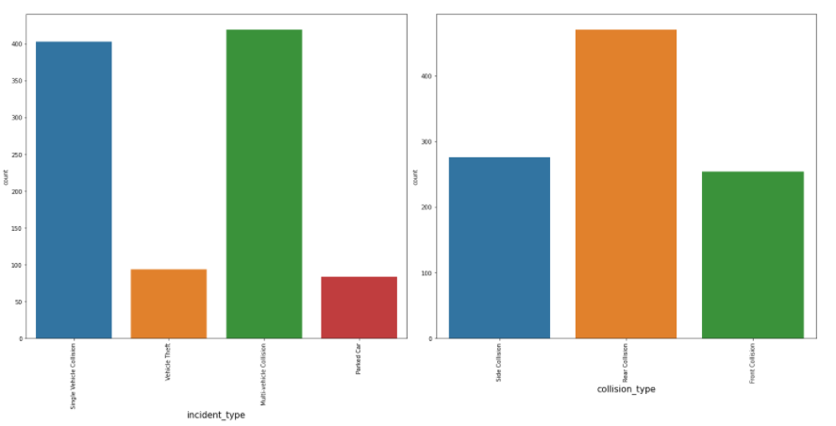
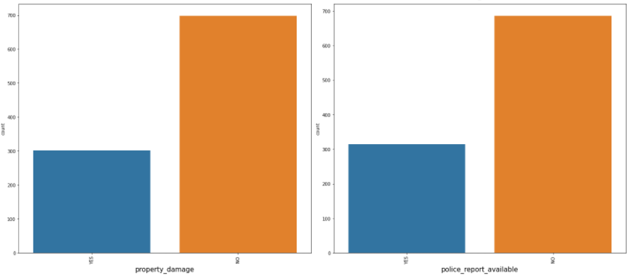
Visualization of the String Values
For the string data, a count plot graph was used as it gives the frequency of the columns. Observations made while analyzing data are -
- Female customers are more than the male customers.
- 753 people have been reported with No Fraud but 247 People have been reported with Fraud.
- 300 customer's property has been damaged and 700 customer's property has not been damaged.
- Around 320 customer's police reports are available and 680 customer's police reports are not available.
- Incidents are high in states like SC, NY and WV.
- Rear Collision is the max collision type.
- The incident severity is Minor damage in most of the cases.
- Police authorities have been contacted the most.
- There are too many categories in columns like auto_model, auto_make, incident_location, incident_date, insured_occupation & insured_hobies. Hence, it is difficult to conclude any observation out of these columns.
Visualization of Int/Float Values
We have used distribution plot graphs to understand data with int/float values. Observations made are –
- Variables policy_bind_year, policy_bind_month, policy_bind_day, auto_year & incident_hour_of_the_day are showing values at a constant rate.
- We could observe negative values in the capital-loss feature.
- Capital-gains consists of values ranging till positive 120000.
- Capital-loss consists of values ranging till negative 130000.
- Variables like number_of_vehicles_involved, bodily_injuries & witnesses have a nominal/categorical type of data.

Bivariate Analysis

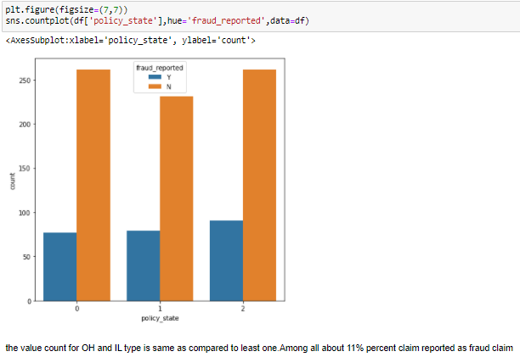
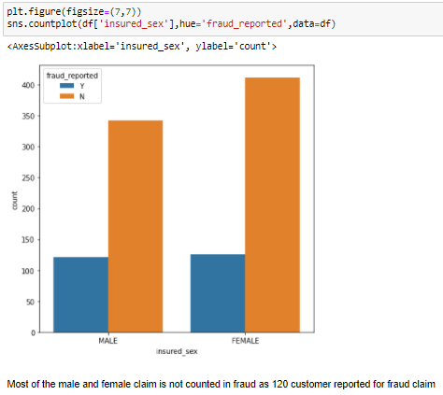
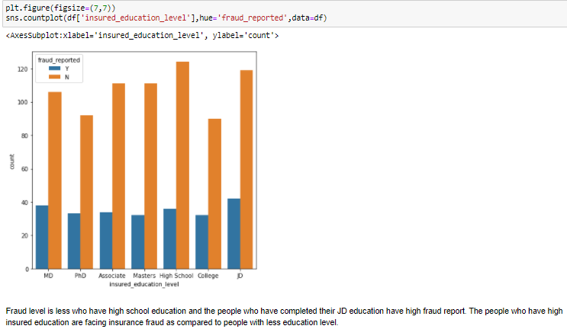

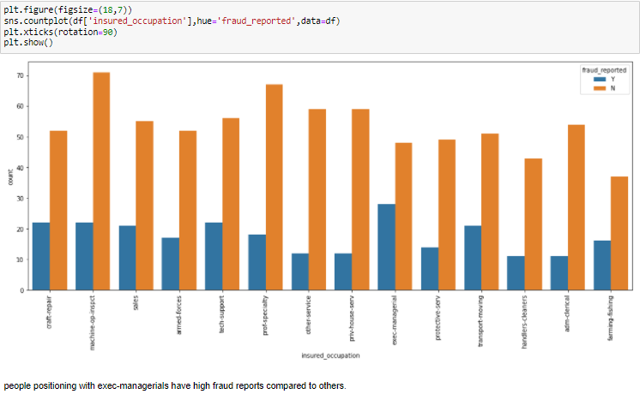
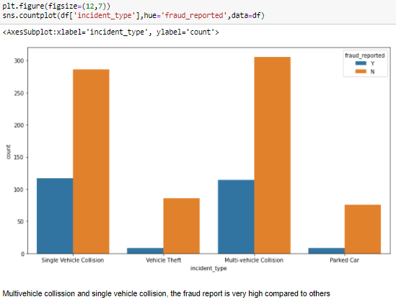
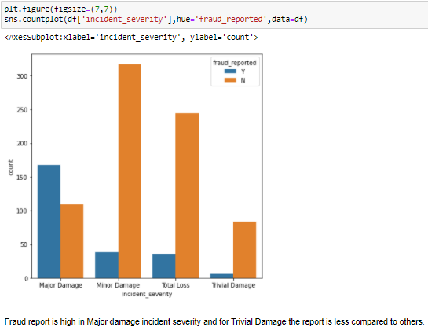
To find the pairwise correlation of all columns in the dataframe

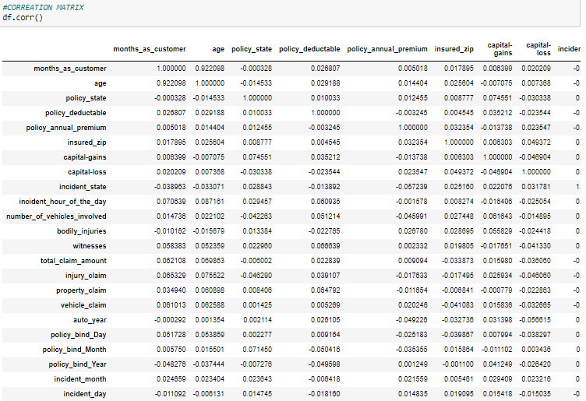
Here, we use data visualization technique which contains values representing various shades of the same color for each value to be plotted. Usually the darker shades in the map represent higher values than the lighter shade. For a very different value a completely different color can also be used.

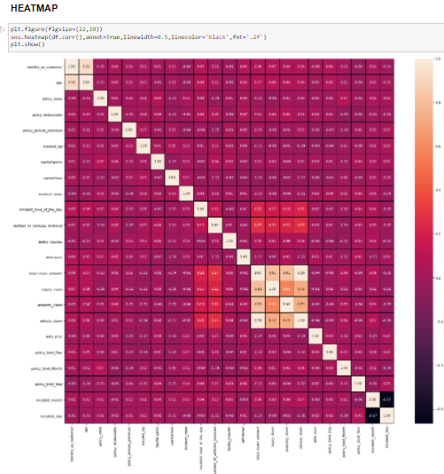
From above plot we see that total claim amount, injury claim, property claim and vehicle claim are highly correlated with each other. Else are least correlated with each other

Outlier Removal
Outliers are data points that are distant from other similar points. They may be due to variability in the measurement or may indicate experimental errors. If possible, outliers should be excluded from the data set.
There are two methods to remove outliers: Zscore and IQR. Here we are using Zscore method for outloer removal as there are few columns having outliers.

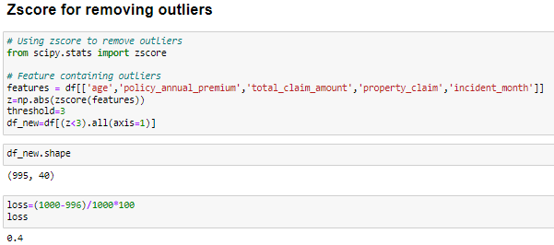
Checking skewness of all the columns
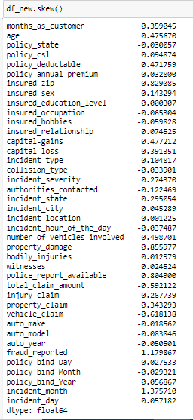
Now we will convert the labels into numeric form so as to convert it into the machine readable form using label Encoder. Machine learning algorithms can then decide in a better way on how those labels must be operated. It is an important preprocessing step for the structured dataset in supervised learning.

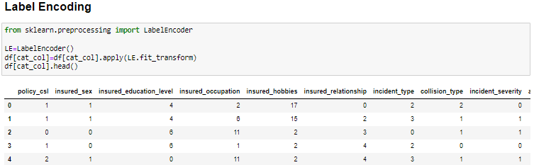
EDA Concluding Remarks
Performing complete EDA on the data (cleaning, visualization and transforming of data), we get final dataset for predicting our model. Concluding observations are -
- Standard deviation of the variables in the dataset is very huge which means that the values in these columns are largely scattered and are not near to the mean values. They are very far away from their mean values.
- The values inside the dataset ranges from high negative values to high positive values. The value ranges are very high within the dataset.
- The min & max values in every feature have huge range differences.
- Due to number of columns count data observation is not very understandable.
- The most negatively correlated variable to the target variable is incident_severity.
- The most positively correlated variable to the target variable is vehicle_claim.

In this project we also plot distribution, count plot and box plot for categorical and numerical column for better understanding.
As dataframe get ready for machine learning process, we will now split the independent variables and target variable into x and y. 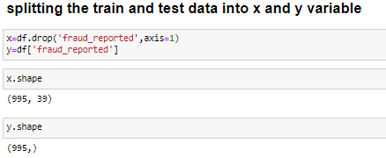
Now,Standard Scaler is used to resize the distribution of values ​​so that the mean of the observed values ​​is 0 and the standard deviation is 1.

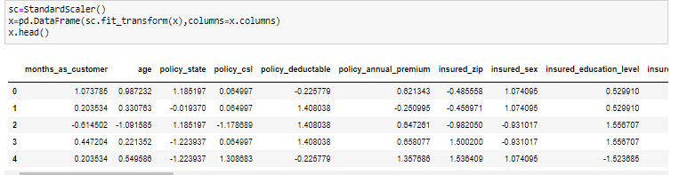

Variance inflation factor: used for diagnosing collinearity/multicollinearity. Higher values signify multicollinearity where 4 columns here have high values. So we remove total claim amount from dataset.
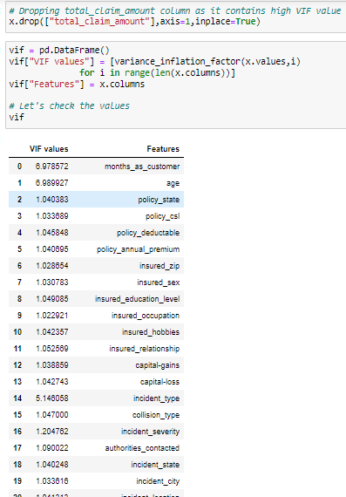
Balancing our imbalanced data

As it is a classification model and data is imbalanced so we have to balance it.There are different algorithms present to balance the target variable. We use the SMOTE() algorithm balance our data.

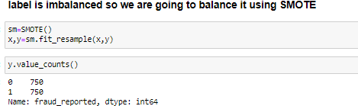

After performing train_test_split we train several machine learning models i.e Logistic Regression, Random Forest Classifier, Decision Tree Classifier, Support Vector Classifier, kNeighbors Classifier, AdaBoost Classifier, Gradient Boosting Classifier, Extra Tree Classifier, eXtreme Gradient Boosting, Bagging Classifier and compare their results.
Out of all, we select Extra Tree Classifier as final model with accuracy 91.66% and its cross validation score 91.20%
Extra tree classifier uses averaging to improve the predictive accuracy and control overfitting.
- Extra Tree Classifier
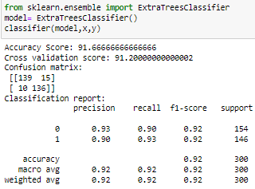

Hyper parameter tuning on best classifier model
Hyper parameter optimization in machine learning intends to find the hyper parameters of a given machine learning algorithm which delivers the best performance as measured on a validation set.
Hyper parameters cannot be directly learned from the regular training process. They are usually fixed before the actual training process begins. These parameters express important properties of the model such as its complexity or how fast it should learn. There are many hyper parameters as if now we are using GridSearchCV.

In GridSearchCV approach, machine learning model is evaluated for a range of hyperparameter values. This approach is called GridSearchCV, because it searches for best set of hyperparameters from a grid of hyperparameters values.

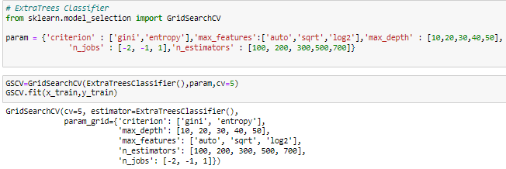
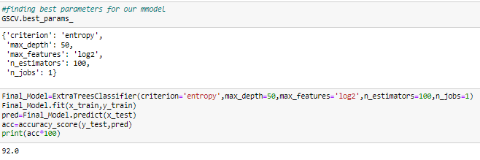
The accuracy after using hyper parameter tuning is 92% for our model.

Confusion matrix
It is used to describe the performance of a classification model on a set of test data for which the true values are known.

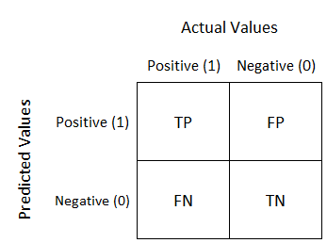

NOTE:
TN/True Negative: the fraud were negative and predicted negative.
TP/True Positive: the fraud were positive and predicted positive.
FN/False Negative: the fraud were positive but predicted negative.
TN/True Negative: the fraud were negative but predicted positive.

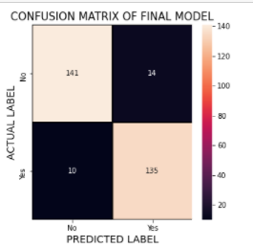

ROC AUC Curve:
Another way to evaluate and compare our binary classifier is provided by the ROC AUC Curve. This curve plots the true positive rate (also called recall) against the false positive rate (ratio of incorrectly classified negative instances).
.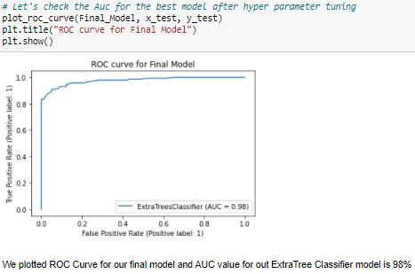
Comparison of original and predicted Dataframe
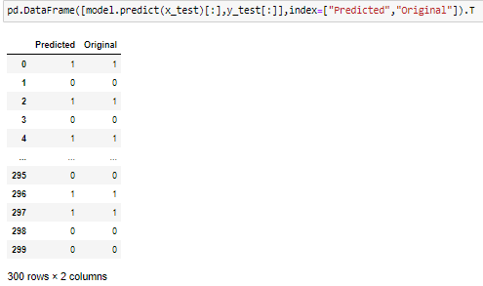

Remarks
This project has built a model that can detect auto insurance fraud. In doing so, the model can help reducing losses for companies. The challenge behind detection is that frauds are far less common as compared to legit insurance claims.

Different classifiers were used in this project: Logistic Regression, Random Forest Classifier, Decision Tree Classifier, Support Vector Classifier, kNeighbors Classifier, AdaBoost Classifier, Gradient Boosting Classifier, Extra Tree Classifier, eXtreme Gradient Boosting, Bagging Classifier. Imbalance data handling were done using oversampling with SMOTE, hyper parameter tuning, and plotting roc curve of the models.

The best and final fitted model was a weighted Extra Trees Classifier with F1 score of 0.92 and a ROC AUC of 0.98. The model performed excellent. The model’s F1 score and ROC AUC scores were the highest amongst the other models. In conclusion, the model was able to correctly distinguish between fraud claims and legit claims with high accuracy.

There is still room for improvement, like doing a more extensive feature engineering, by comparing and plotting the features against each other and identifying and removing the noisy features.

**********************

